Name: ________________________ Năm học 2019 - 2020

Class: ____

**BÀI LUYỆN TẬP TIẾNG ANH KHỐI 4**

**Unit 8: I’d like a melon!**

***Grammar***

1. **Choose a/an/some. Write the words in the correct boxes.**

|  |
| --- |
| **egg lemon orange banana meat cereal noodles apples pastry onion cucumber rice garlic bean sprouts melon bread sauce lemons mushrooms** |

**Uncountable Noun**

**Countable Noun**

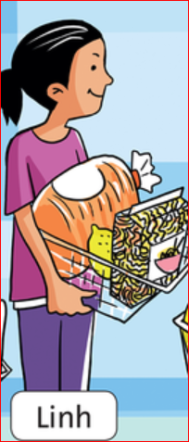

1. **Look at the picture and complete the sentence.**
2. Linh’d like ________ _________.
3. She’d like ________ _________.
4. She’d like ________ _________.
5. **Look at the picture and write “ True or False”**

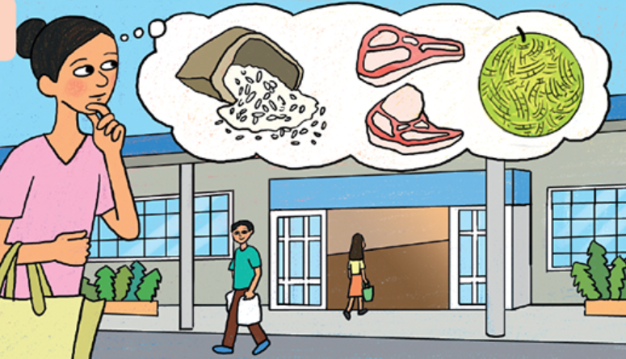

1. She’d like some rice. ____________
2. She’d like some lemons. ____________
3. She’d like an apple. ____________
4. She’d like a pear. ____________
5. She’d like some meat. ____________
6. 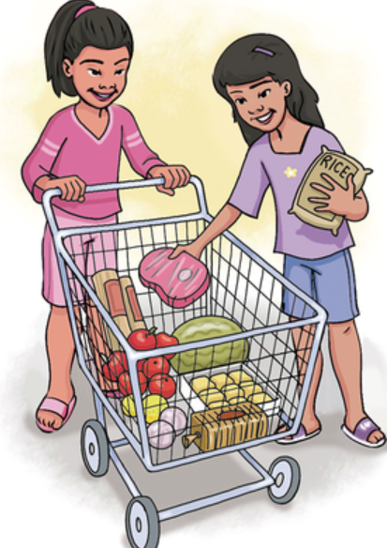**Look at the picture and answer the question “What would they like?”**

They’d like ……………………………..

…………………………………………..

…………………………………………..

…………………………………………..

…………………………………………..

…………………………………………..

1. **Answer the question about yourself.**
2. Would you like some noodles?

……………………………………

1. What would you like?

……………………………………

Địa chỉ mail thầy Sơn Anh Văn: tnhson86@gmail.com

Địa chỉ mail cô Hạnh Anh Văn: [hanh_hoabinh@live.com](mailto:hanh_hoabinh@live.com)